Instructions for the preparation of an extended abstract for the 8th World Congress on Conservation Agriculture
N.M. Surname¹, N.M. Surname² (Times New Roman, 11pt, centered)
1.Department, Center / University, Address. (Times New Roman, 9pt, justified)
2.Department, Center / University, Address.
Corresponding author: E-mail. (Times New Roman, 10pt, justified)

Keywords: Instructions, Conservation Agriculture, Extended abstract, Congress, Template

- INTRODUCTION
The extended abstract will be edited using Microsoft Word Format. NO OTHER FORMATS WILL BE ACCEPTED. The size of the file to be sent electronically should not exceed FIVE megabytes (5 MB). The extended abstract should be written following the instructions for extended abstracts that can be found at the conference website: www.8wcca.org. Authors must upload the extended abstract file correctly formatted online through the conference website. The deadline for uploading the extended abstract is given at the conference website. The organizers do not commit themselves to include in the proceedings any extended abstract received later than this deadline. At least one of the authors must register and pay his/her registration fee before the deadline for their extended abstract to be included in the final program of the conference.
- GENERAL SPECIFICATIONS
  - Extended abstract size and format
The extended abstract must be written in English. The size of the manuscript must be A4, using Times New Roman font and it should be typed in one column with single spacing and the following margins.
Left margin 3 mm
Right margin 3 mm
Top margin 2.5 mm
Bottom margin 2.5 mm
The maximum number of pages allowed is 7, including figures and tables. Submitted extended abstracts must be in Microsoft Word Format. No other formats will be accepted. The size of the file to be sent electronically should not exceed five megabytes (5 MB).
Pages must not be numbered
- TITLE, AUTHORS, AFFILIATION, KEYWORDS
The first page must contain the Title, Author(s), Affiliation(s) and Keywords.
  - Title
The title should be written centered, in 14pt, bold. It should be single spaced if the title is more than one line long.
  - Author
The author’s name should include name initial, middle initial and surname. It should be writ-ten justified, 11pt.

  - Affiliation
Author’s affiliation should be written justified, 9pt.
  - Corresponding author
The corresponding author email must be included in italics, 10pt, justified.
  - Keywords
Please, write no more than five keywords. They should be written left aligned, in 11pt, Italic.
- PAPER BODY
  - Headings
    - Main headings
The main headings should be written left aligned, in 12pt, bold and all capital letters.
    - Secondary headings
Secondary headings should be written left aligned, 12pt, bold, with an initial capital for first word only.
    - Editorial Headings
The first page of the extended abstract will include the Editorial Heading, as shown in the first page of these instructions. In addition, successive pages will include the name of the authors.
  - Text
The normal text should be written single-spaced, justified, using 12pt Times New Roman in one column. There is no interparagraph spacing.
  - Figures and tables
Figures and tables must be centered. All figures should be numbered consecutively and captioned. The caption title should be written centered, in 10pt Roman. Figure captions should be below the figures and table captions should be above the table. A 6pt space should separate the figure from the caption, and a 12pt space should separate the upper part of the figure and the bottom of the caption from the surrounding text. All figures and tables should be placed after their first mention in the text. Large figures and tables may span across both columns. Scanned images (e.g. line art, photos) can be used if the output resolution is at least 600 dpi.

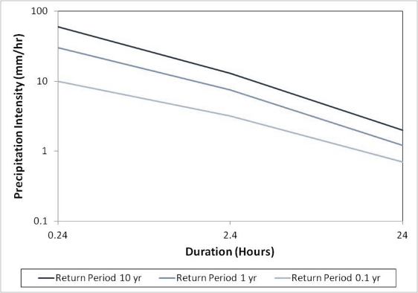
Fig. 1 The caption should be placed below the figure.
They should be referred to in the text as, for example, Fig. 1 or Figs. 1~3.
Table 1. Caption should be placed before the table.
 | A | B | C
(1) | 150 | 16.3 | 18.2
(2) | 123 | 13.5 | 16.9
(3) | 162 | 19.2

  - Equations
Equation numbers should be Arabic numerals enclosed in parentheses on the right-hand margin. They should be cited in the text as, for example, Eq. (1), or Eqs. (1)~(3). Equations start from the left of the column
The following example is a single line equation:
The next example is a multi-line equation:
  - References

References should be quoted in the main text in brackets, using surname and name initial of the first author (i.e.: Holland, J.M). References should appear alphabetically in a separate bibliography at the end of the extended abstract in Times New Roman 11pt. 12pt space should separate each reference
Please ensure that every reference cited in the text is also present in the reference list (and vice versa)

Holland, J.M. 2004. The environmental consequences of adopting conservation tillage in Europe: reviewing the evidence. Agriculture Ecosystems & Environment. 103, 1-25.
Maetens, W., Poesen, J., Vanmaercke, M., 2012. How effective are soil conservation techniques in reducing plot runoff and soil loss in Europe and the Mediterranean? Earth-Science Reviews. 115, 21-36.
Sadeghi, A.M., Isensse, A.R., 1997. Alachlor and Cyanazine persistence in soil under different tillages and rainfal regimes. Soil Science 162, 47-54.

